Question:1

Formulate the problem(define initial state, goal state, successor function ) and draw a diagram of the complete state space (without repeated states).

Ans:

Initial State: The initial state is defined by specifying the value for each feature for the initial time.Like from the missionaries and cannibals problem initial state is (3,3,1).

Goal State: A planning problem usually involves starting in some initial state and trying to arrive at a specified goal state or any state in a set of goal states. The actions are selected in a way that tries to make this happen.Like from the Lion, Lamb and grass problem goal state is (0,0,0).

Successor function: A successor function is a description of possible actions, a set of operators. It is a transformation function on a state representation, which convert it into another state. The successor function defines a relation of accessibility among states.

Draw a diagram of the complete state space:

For Lion, Lamb and grass problem:

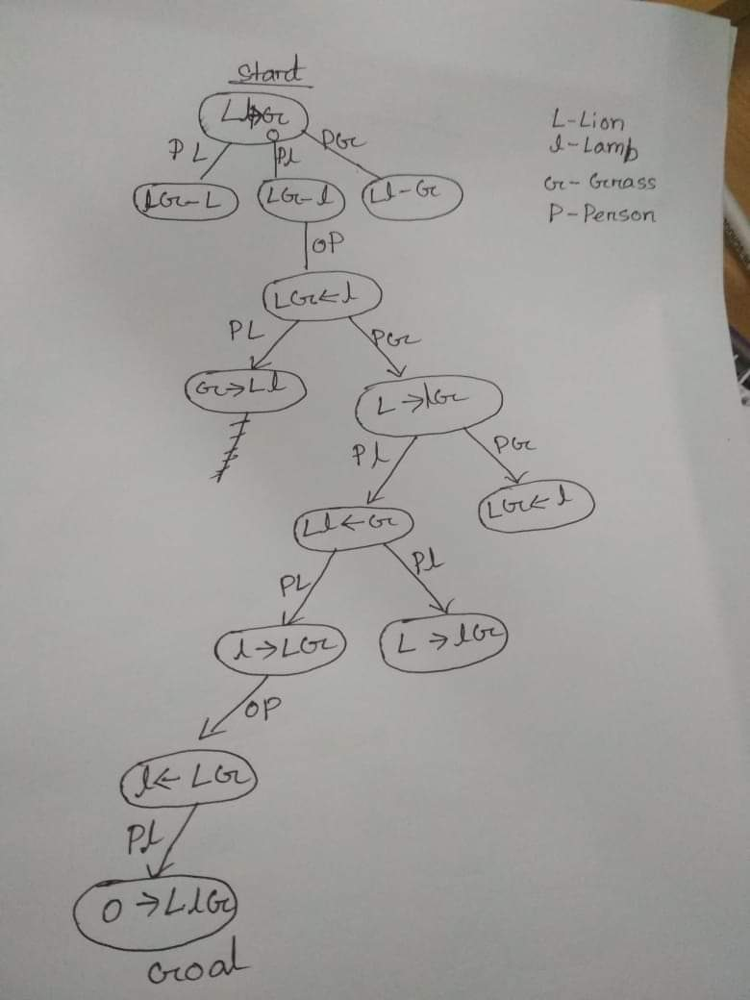

The missionaries and cannibals problem:

